GRX (Group Excess) Salesforce Integration: Manual Process Design Document
Package: pkg_stone_river_data_load (schema STAGE_MISREG) | Prepared by: Pawan | Date: November 11, 2026 | Status: Draft v1.0 for client review

1. Purpose and scope
This document describes the changes made to the Stone River (SRM) monthly Manual process so that Group Excess (GRX) policies sourced from Salesforce (source system keys 23 and 24) flow through the existing Manual premium and claims process. It also explains the reasoning behind each design decision.
In scope: the four Manual procedures of pkg_stone_river_data_load: prc_premium_feed_load, prc_claims_feed_load, prc_premium_control_load and prc_claims_control_load.
Out of scope: the DC / CIP (Instanda) procedures, WINS, and DataStage job changes. These were reviewed for impact (Sections 8 and 9) but are not modified by this change.

2. Executive summary
- Problem: Before this change, Salesforce GRX was rejected by both selection rules. Premium admitted GRX only from the source-system names Manual and Program Connect; claims admitted only source system keys 6, 7 and 15.
- Solution: A narrowly scoped Salesforce admission rule was added to all four Manual procedures. A Salesforce row is admitted only when the source-system name is SF Admitted or SF Non-Admitted, the source system key is 23 or 24, and the policy type is GRX.
- Month basis: Salesforce claim transactions are selected on the PCS accounting month (pcs_month_acctng_ct). All other sources keep the existing accounting month (month_acctng_ct).
- Unchanged: output record layouts, product mapping (GRX to GEX to line of business 171), orchestration order and the structure of the control totals.

Step | Procedure | Log module | What it builds | Target table (STAGE_MISREG)
1 | prc_premium_feed_load | MANUAL_PRM | Fixed-width premium records from TTRANSACTION, grouped by endorsement, policy, coverage, transaction type and dates | stage_premium_feed_details
2 | prc_claims_feed_load | MANUAL_CLAIMS | Loss records from TCLAIM_TRANSACTION in five blocks: paid loss, paid expense, salvage and subrogation, other recovery, reserves | stage_loss_feed_details
3 | prc_premium_control_load | MANUAL_CONTROL | Product-level premium control totals, using the same selection as step 1 | stage_premium_control_details
4 | prc_claims_control_load | MANUAL_CLAIMS_CONTROL | Product-level loss control totals, using the same selection | stage_loss_control_details

4. End-to-end process flow
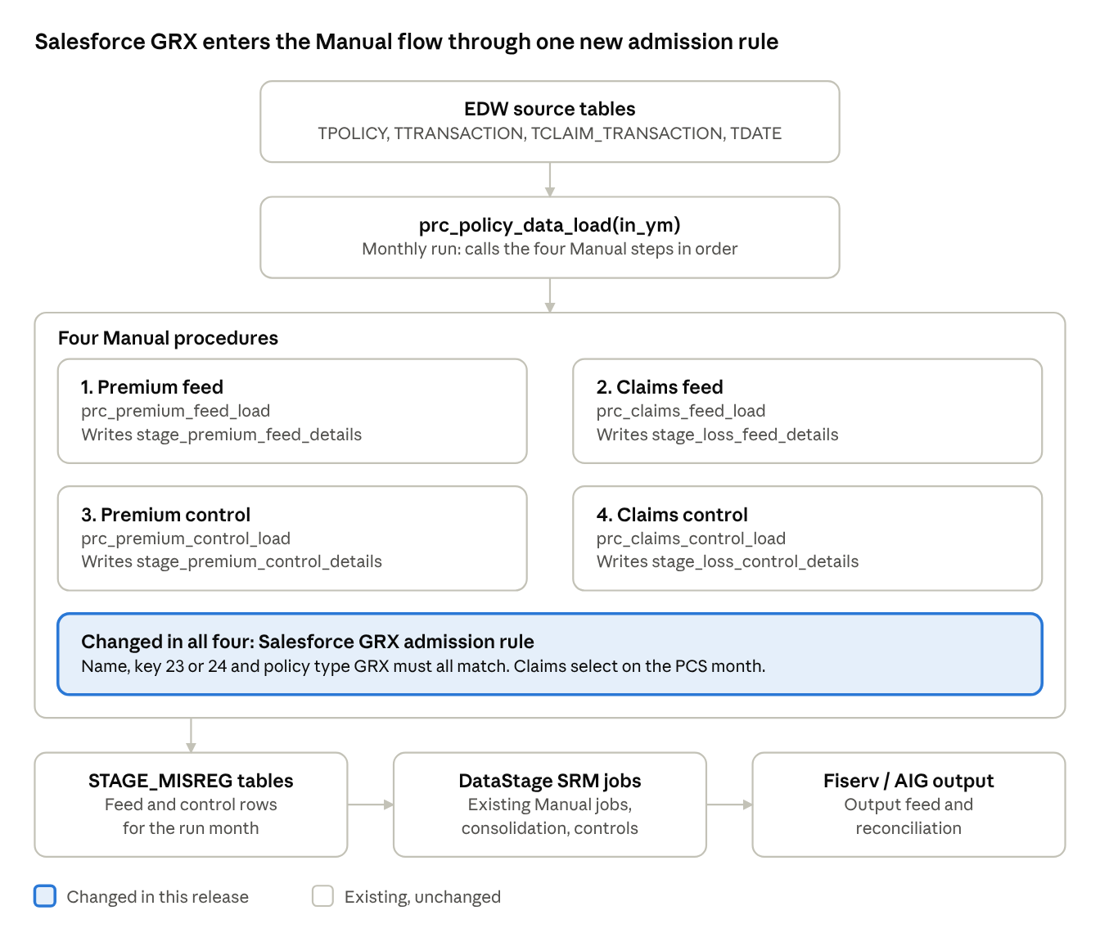
Manual process flow: 4 procedures, 1 change point
The Salesforce rule is applied inside the four Manual procedures (highlighted). The orchestrator, stage tables and DataStage jobs around them keep their existing design. The numbered steps below give the detail.
- Source data (EDW): TPOLICY, TTRANSACTION, TCLAIM_TRANSACTION, TCLAIM, TPOLICY_TYPE, TUW_COMPANY, TDATE and related reference tables.
- Month selection: Premium uses the accounting-date month (year_month_ct); claims use month_acctng_ct (existing sources) or pcs_month_acctng_ct (Salesforce).
- Stage tables: four feed and control tables in STAGE_MISREG.

Salesforce GRX admission rule
Check | Premium (feed and control) | Claims (feed and control)
Run month | year_month_ct = in_ym on the accounting date | Salesforce: pcs_month_acctng_ct = in_ym. Other sources: month_acctng_ct = in_ym. Reserves use <= in_ym (cumulative) on the same columns
Source system key | IN (23, 24) | IN (23, 24)
Source system name | SF Admitted or SF Non-Admitted | SF Admitted or SF Non-Admitted
Policy type | GRX | GRX
Amount | premium_am <> 0 | The amount for the block (loss paid, expense paid, recovery or reserve) is non-zero
Existing exclusions kept | Unchanged | HP policy type excluded; UW company suffix 51 and 61 excluded

5. Design changes

Broke the changes down into 3 clear steps matching your 3 screenshots:

Adding 'GRX' in the Premium procedures (prc_premium_feed_load & control).
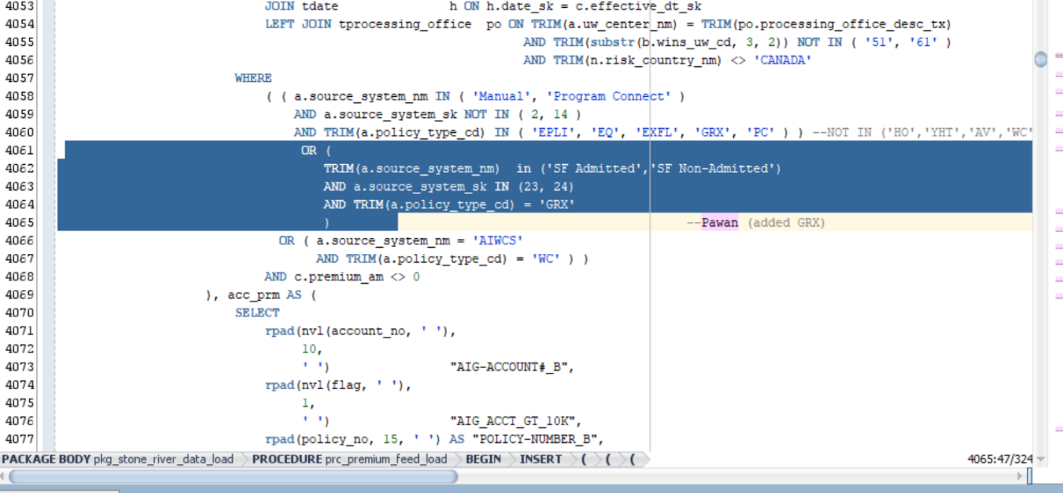
- Premium selection (P-1 and P-2), before:
- WHERE
( ( a.source_system_nm IN ( 'Manual', 'Program Connect' )
AND a.source_system_sk NOT IN ( 2, 14 )
AND TRIM(a.policy_type_cd) IN ( 'EPLI', 'EQ', 'EXFL', 'GRX', 'PC' ) )
OR ( a.source_system_nm = 'AIWCS'
AND TRIM(a.policy_type_cd) = 'WC' ) )
AND c.premium_am <> 0
- After:
- WHERE
( ( a.source_system_nm IN ( 'Manual', 'Program Connect' )
AND a.source_system_sk NOT IN ( 2, 14 )
AND TRIM(a.policy_type_cd) IN ( 'EPLI', 'EQ', 'EXFL', 'GRX', 'PC' ) )
OR ( TRIM(a.source_system_nm) IN ( 'SF Admitted', 'SF Non-Admitted' ) -- new
AND a.source_system_sk IN ( 23, 24 ) -- new
AND TRIM(a.policy_type_cd) = 'GRX' ) -- new
OR ( a.source_system_nm = 'AIWCS'
AND TRIM(a.policy_type_cd) = 'WC' ) )
AND c.premium_am <> 0

Adding 'GRX' in the Claims procedures (prc_claims_feed_load & control).
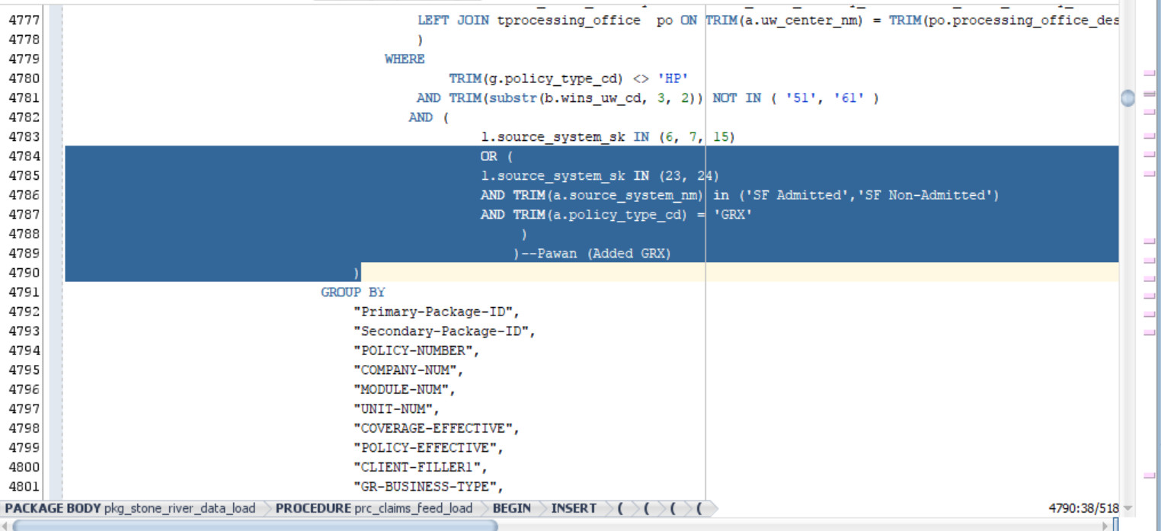

We replaced it with the OR condition splitting month_acctng_ct (NOT IN (23,24)) and pcs_month_acctng_ct (IN (23,24)).
Premium uses the accounting-date month (year_month_ct); claims use month_acctng_ct (existing sources) or pcs_month_acctng_ct (Salesforce).
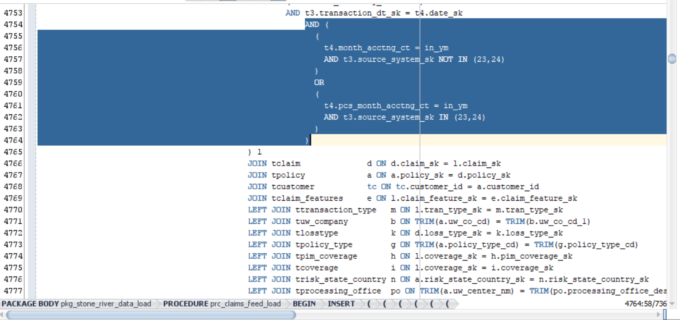

DataStage Job Modifications for GRX Integration

1. GRX Integration - Transformer Logic Updates

The following logic was implemented in the transformer stage for both the srm_manual_premium_ds and srm_manual_loss_ds data sets.
Field | Logic
Sap_Company_Cd | If NullToZero(Lkp7_out.DUMMY) <> 0 And Lkp7_out.DUMMY = 1 Then (If (NullToZero(Lkp7_out.UW_CO_CD) = 'MSIC') Then '3911' Else Lex_Sap_Company_Cd) Else Sap_Company_Cd
Issuing_Legal_Entity_Cd | IF(nulltoZero(Lkp7_out.DUMMY) <> 0 and (Lkp7_out.DUMMY)= 1) then (If (NullToZero(Lkp7_out.UW_CO_CD) = 'MSIC') Then '40' Else Lex_Issuing_Legal_Entity_Cd) else Issuing_Legal_Entity_Cd
Worldwide_Company_Cd | IF(nulltoZero(Lkp7_out.DUMMY) <> 0 and (Lkp7_out.DUMMY)= 1) then (If (NullToZero(Lkp7_out.UW_CO_CD) = 'MSIC') Then '005908' else Lex_Worldwide_Company_Cd) else Worldwide_Company_Cd

(See attached screenshot for reference)
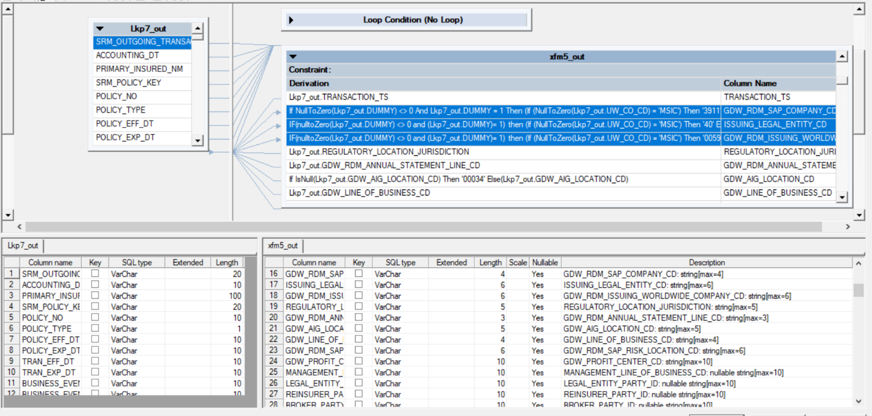

2. Job: srm_instanda_premium_update

Source Query Updates

Modified the WHERE clause to include 'MNUL' as a System_ID.

SQL

SELECT SRM_OUTGOING_TRANSACTION_ID, policy_no, POLICY_EFF_DT, system_id

FROM #PS_PCG_EDW.$PCG_EDW_Stage_Schema#.STAGE_SRM_PREMIUM_LOSS

WHERE System_ID IN ('DC','MNUL') AND accounting_month='#AccMnth#';

Added a CASE statement to derive System_ID as 'SLFS' (Salesforce) when source_system_sk is 23 or 24.

Transformer Logic Updates

SRM Outgoing Transaction ID:

MP prefix is converted to SP.

ML prefix is converted to SL.

For all others, D is replaced with I.
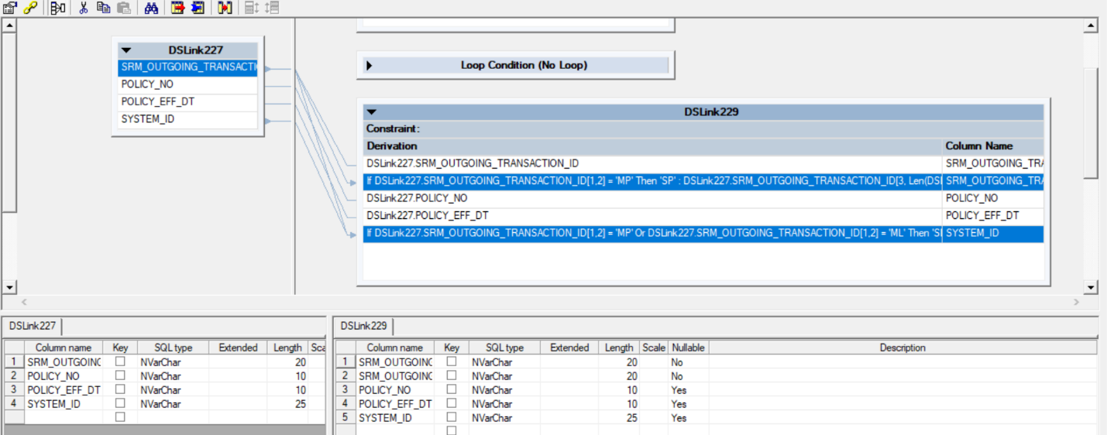

If DSLink227.SRM_OUTGOING_TRANSACTION_ID[1,2] = 'MP' Then 'SP' : DSLink227.SRM_OUTGOING_TRANSACTION_ID[3, Len(DSLink227.SRM_OUTGOING_TRANSACTION_ID)]

Else If DSLink227.SRM_OUTGOING_TRANSACTION_ID[1,2] = 'ML' Then 'SL' : DSLink227.SRM_OUTGOING_TRANSACTION_ID[3, Len(DSLink227.SRM_OUTGOING_TRANSACTION_ID)]

Else Ereplace(DSLink227.SRM_OUTGOING_TRANSACTION_ID, 'D', 'I')

System ID:

Set to 'SLFS' if the transaction ID prefix is MP or ML.

If DSLink227.SRM_OUTGOING_TRANSACTION_ID[1,2] = 'MP' Or DSLink227.SRM_OUTGOING_TRANSACTION_ID[1,2] = 'ML' Then 'SLFS'

Else DSLink227.SYSTEM_ID
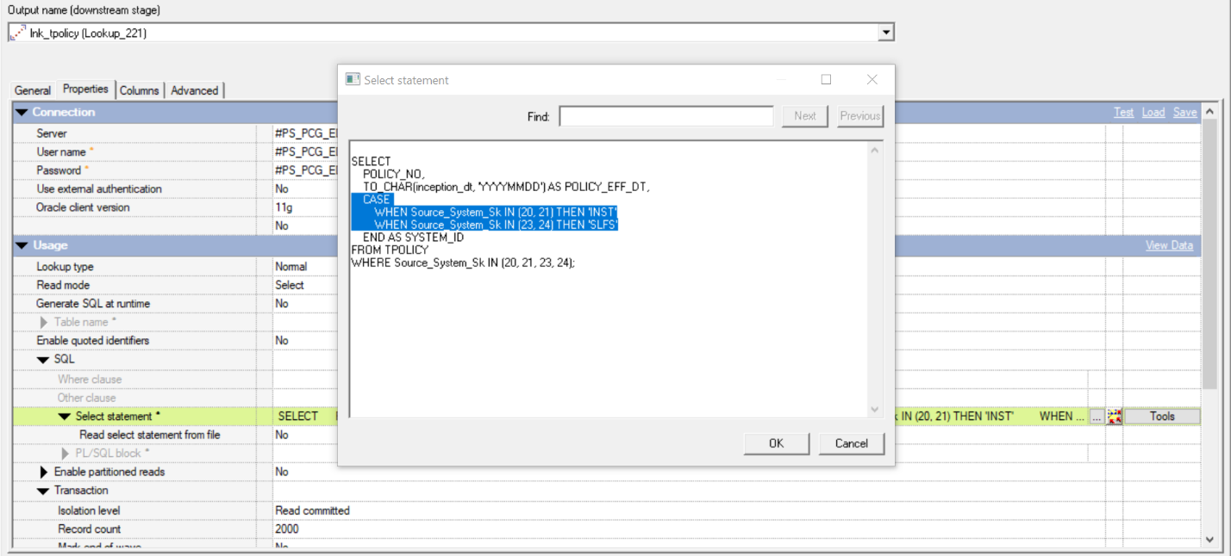(See attached screenshot for reference)

![image.png](image.png)

3. Job: srm_instanda_error_update

The exact same changes that were applied to the srm_instanda_premium_update job were replicated in the srm_instanda_error_update job.

